Highgate Community Primary School Year 3
Key Question: Could Jesus heal people?
Christianity: Incarnation

Vocabulary |  | 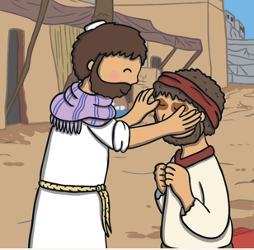  Jesus heals the blind man  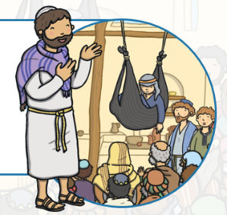  Jesus cures the paralysed man | Interesting Facts
Jesus lived over 2000 years ago.

Jesus lived in the modern day country called Israel which is also known as the Holy Land.

Many of his miracles happened near the sea of Galilee

The four Gospels are Matthew, Mark, Luke and John.

Christians believe that Jesus performed other miracles
including: walking on water, turning water into wine and feeding 5,000 people from 2 loaves of bread and 5 fish.
Bible | The Bible is the holy book on which the Jewish and Christian religions are based.
blind | Someone who is blind is unable to see because their eyes are damaged.
disciples | The 12 special followers of Jesus Christ.
The Gospels | The four books in the Bible which describe the life and teachings of Jesus Christ.
heal | To become healthy again.
incarnation | The Christian belief that God took human form in the shape of Jesus Christ.
miracle | A miracle is something that happens outside the usual rules of nature/expectations
paralysed | Unable to move
perform | To carry out an action or task.
saviour | A person who rescues another person or a thing from danger or harm.
sin | An action or type of behaviour which is believed to break God’s wishes.
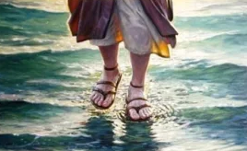  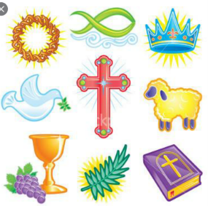  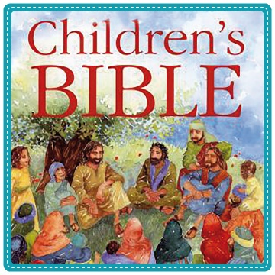  Jesus performed other miracles  Christian Symbols |  | Key Knowledge
Christians believe that Jesus was the son of God in human form. He was sent from Heaven to carry out his father’s work.

In the gospel of John it is said that Jesus performed seven miracles.

Some Christians believe that Jesus actually performed the miracles. Others believe that the miracles are special stories that teach Christians about God’s power and love.

