Highgate Community Primary School Year 3 Would celebrating Diwali at home and in the community
bring a feeling of belonging to a Hindu child?
Vocabulary |  | 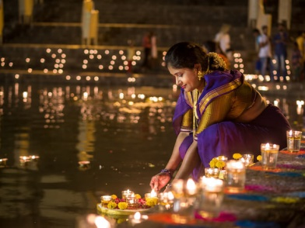  A Hindu worshipper lights Diva Lamps  .  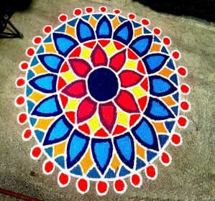  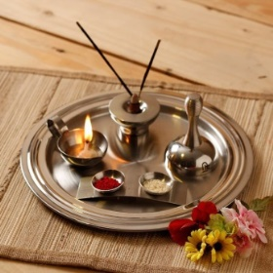  A Puja Tray A Rangoli Pattern | Key Facts
Diwali takes place every year in late October or early November depending on the cycle of the moon.

Diwali marks the Hindu new year.

Diwali lasts for 5 days.

It is the largest and most celebrated festival in India.

The city of Leicester hosts the biggest Diwali celebrations outside of India.

Sikhs also celebrate Diwali

Diwali | Festival of Light.
Ramayana | Hindu tale that tells the story of Rama and Sita.
Rama | Lord Rama, the Hindu God, is the hero of the Ramayana.
Sita | The wife of Rama who was kidnapped by Ravana the ten headed demon .
Lakshmi | The Goddess of wealth and good fortune.
Ravana | Ten headed demon king of Lanka.
Rangoli Patterns | Patterns created on the floor in living rooms or courtyards using materials such as coloured rice, dry flour, coloured sand or dry petals
Diva Lamp | Oil lamp usually made from clay with a cotton wick dipped in ghee or vegetable oil.
Puja Tray | Puja means worship. During worship, Hindus use many items, which are kept on a Puja tray. The items include a bell, a pot of water, a diva lamp, an incense burner, a pot of kum kum powder, and a spoon. Puja involves offering light, incense, flowers and food to the deities (the gods).
Mandir | Hindu place of worship (temple)
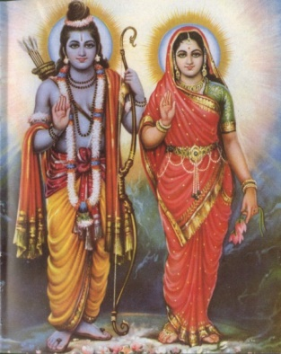  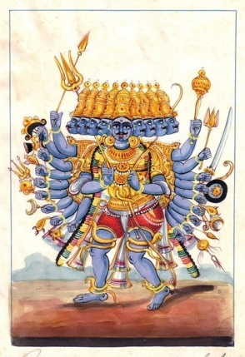  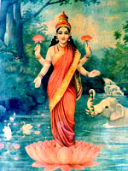  Rama and Sita Lakshmi Ravana |  | Key Knowledge
Hindus all over the world come together to celebrate Diwali.

At Diwali it is tradition to decorate and illuminate homes, visit the local temple for prayers, wear new clothes and share meals with families and friends. Children get small gifts and sweets.

This festival is celebrated with diva lamps, sparklers, firecrackers and fireworks

Diwali celebrates the victory of light over darkness and the triumph of good over evil.

