Highgate Community Primary School Year 3 The Bronze Age and The Iron Age
Vocabulary |  | 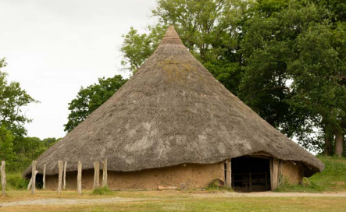  Recronstruction of an Iron Age roundhouse  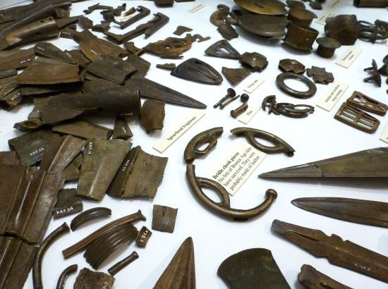  .  The Isleham hoard,  discovered in Cambridgeshire in 1959 | Key Facts
The Bronze Age is the name given to the period of time between the Stone and Iron Ages.

In Britain, the Bronze Age started around 2100BC and ended around 650BC.

Bronze is an alloy or mixture of tin and copper.

The Iron Age is the name given to the time period (from approximately 500 BC to 43 AD in Britain) where iron became the preferred choice of metal for making tools.
smelting | The process of extracting a metal from an ore by heating.
bronze | Bronze is a yellowish-brown metal which is a mixture of copper and tin.
ore | Ore is rock or earth from which metal can be obtained.
wattle and daub | A form of wall construction consisting of interwoven twigs plastered with a mixture of clay, lime, water, dung and chopped straw.
iron | Iron is a hard, dark-grey metal. It is used to make steel, and also forms part of many tools, buildings, and vehicles.
roundhouse | Large families lived in a roundhouse. The walls were made of daub and the roof of straw. A fire would be lit in the middle of the roundhouse for cooking and heating.
hill fort | Hill forts were built on hilltops and surrounded by huge banks (mounds) of soil and ditches. They were protected by wooden walls which kept enemies out.
crannogs | An ancient lake or bog dating from the Bronze Age.
broch | A circular dry-stone tower large enough to serve as a home.
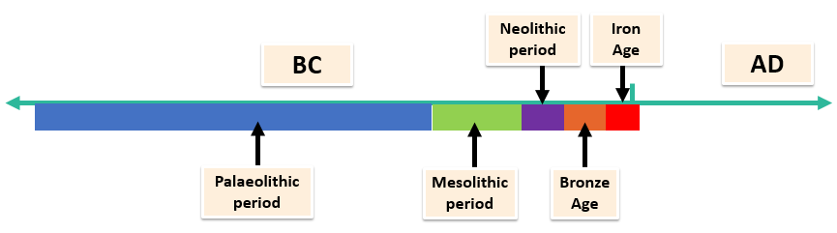 |  | Key Facts
Around 2500 BC, people began to smelt (remove the metal from the ore) copper.

The Bronze Age is a time period when bronze replaced stone as the preferred material for making tools and weapons. This led to improvements in agriculture and brought with it changes in the way people live.

Most Iron Age people worked and lived on small farms.

During the Iron Age people began to produce and store more grain than they could use, they were able to trade. Land ownership and grain production became the way to gain wealth and power.

