Highgate Community Primary School Year 3 Science: Rocks and soils
Vocabulary |  |  | Key Facts  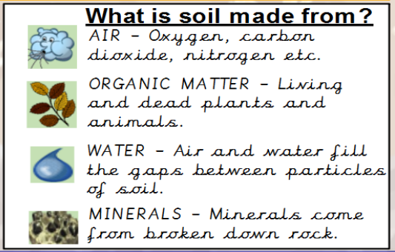
fossil​ | A fossil is the preserved remains or traces of a dead organism.​
soil​ | Soil consists of a mix of organic material (decayed plants and animals) and broken bits of rocks and minerals.​
crystals​ | Crystals are a special kind of solid material where the molecules fit together in a repeating pattern.​
sedimentary​ | Sedimentary rocks are made when sand, mud and pebbles get laid down in layers. Over time, these layers are squashed under more and more layers.​
metamorphic​ | When a rock experiences heat and pressure, it becomes a metamorphic rock. All metamorphic rocks start as another type of rock.​
igneous​ | Igneous rock is formed when magma cools and solidifies, it may do this above or below the Earth's surface.​
organic matter​ | Organic matter is matter that has come from a recently living organism. It is capable of decaying.​
.  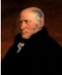  Key Scientist: William Smith (1769 – 1839) William was known as the 'Father of English Geology'. Geology is the name for the study of rocks. He collected fossils. He realised that he could tell the age of a rock by looking at the fossils inside it. |  | 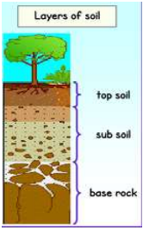  . | Other key Facts
Fossils: Fossils are the remains or The impression left by a prehistoric plant or animal in a rock.
1) An animal, creature or plant dies and ends up at the bottom of the sea. It gets covered by a layer of sediment.
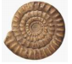
2) Over time, more layers of sediment form on top and the only part to remain are the bones.
3) Over a long period of time, the sea recedes (goes back) leaving the rock.
4) Erosion and weathering of the rock means the fossil can now be seen!

