Highgate Community Primary School Year 3 Science: Parts of plants
Vocabulary |  | 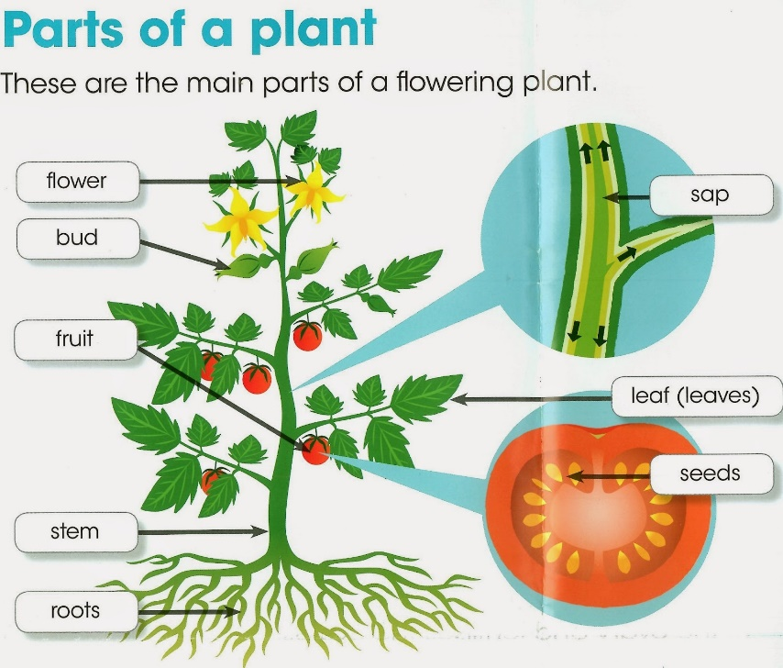
roots | The root is the part of a plant that typically lies below the surface of the soil.
stem | The stem is the plant axis that bears buds and shoots with leaves.
nutrients | Nutrients are the food the plant wants. Most of the plant’s nutrients comes from the soil.
pollination | Pollination is the act of transferring pollen grains from the male anther of a flower to the female stigma.
seed dispersal | Seed dispersal is the movement or transport of seeds away from the parent plant.
fertiliser | Fertilisers are used to increase the rate of a plant’s growth.
seed formation | A seed is a small baby plant enclosed in a covering called the seed coat, usually with some stored food.
stigma | The stigma is usually sticky and receives pollen.
anther | The stamen has a pollen producing structure at the end which is called the anther. | Key Facts
soil | The soil has water and nutrients that a plant needs to grow healthily. | Plants need light, water, and warmth to grow.  Water is taken up into the plant through the roots. The roots also keep the plant steady and upright in the soil.  The stem is important because it carries water up from the roots and nutrients to different parts of the plant. It also can help to keep the plant standing tall and upright, so it can get lots of light.  The leaves take in lots of light for the plant. It uses this light, together with air and water, to make food for the plant. This is called photosynthesis.  Lots of plants have flowers. These are used to attract insects to the plant, so that the insects can move pollen around to other plants of the same species – a process called pollination.  Seeds are the result of plant reproduction and when they germinate, or begin to grow, they will develop into new plants.  There are lots of different ways that seeds can disperse to new areas including: wind, travelling on animal fur or by being eaten by animals and pooed out!
photosynthesis | Photosynthesis is the way that green plants make their food using sunlight.
