Highgate Community Primary School Year 3 Science: Movement and feeding
Vocabulary |  | 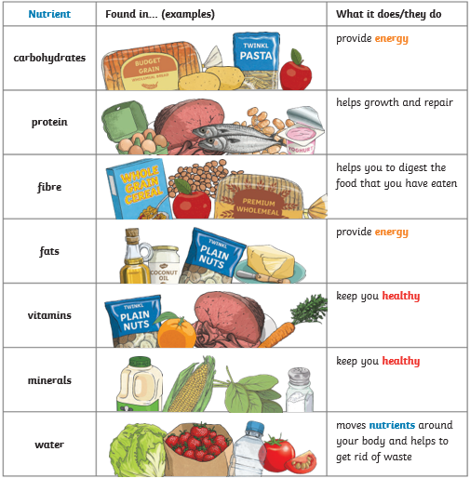  Food Groups | Human skeleton
 |  |  | 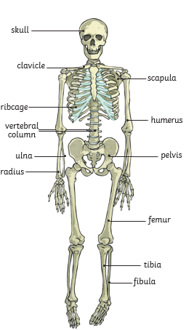
healthy | In a good physical and mental condition
nutrients | Substances that animals need to stay alive and healthy
energy | Strength to be able to move and grow
nutrition | Food necessary for health and growth
skeleton | Bones surrounding our important organs
muscle | Soft tissue in the body that contracts and relaxes to cause movement of the skeleton
contract | When a muscle becomes smaller, shorter and tighter
vertebrate | Animals with backbones
invertebrate | Animals without backbones
tendons | Cords that join muscles to bones
joints | Areas where two or more bones are fitted together | Key Facts
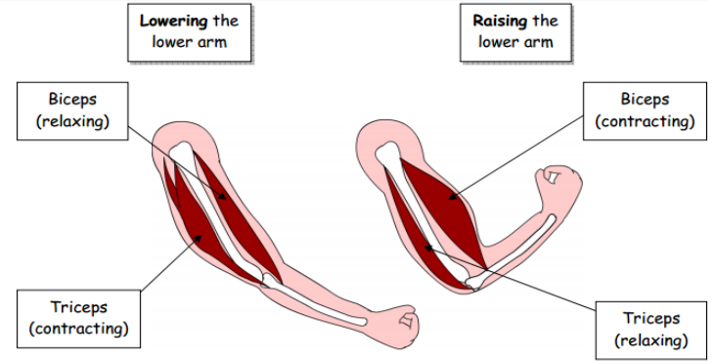 |  | 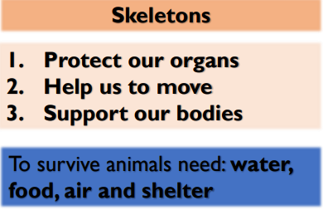  •Living things need food to grow and to be strong and healthy  •Plants can make their own food, but animals cannot  •To stay healthy, humans need to exercise, eat a healthy diet and be hygienic

