Highgate Community Primary School Year 3 Science: Light and shadows
Vocabulary |  | 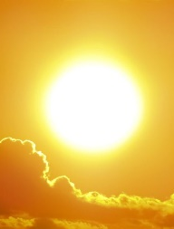  Sources of light  .  Natural  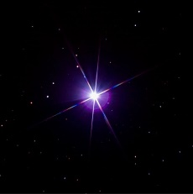  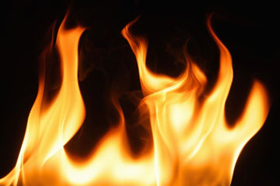  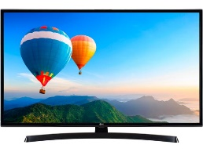  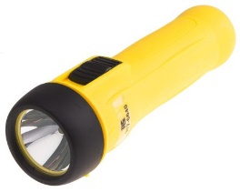  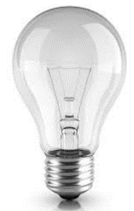  Artificial | Key Facts
Some objects like glass are transparent which means light can shine through them.

Our main source of light on Earth comes from the sun.

Because light travels in straight lines, when it hits an object, it is blocked. It can’t bend around the object so it casts a shadow.

A mirror is not a light source. It reflects light so doesn’t create it.
reflection | When a ray of light hits a surface and bounces off.
shadows | A shadow is a dark shape on a surface that is formed when an object blocks out the light.
light source | Something that provides light, whether it be a natural or artificial source of light (e.g. the sun, a torch)
opaque | This is the name given to objects that do not allow light to pass through them. They block light and create shadows.
transparent | This is the name given to objects which light can travel through.
translucent | This is the name given to objects which some light can travel through.
nocturnal | If something is nocturnal, it is mainly active at night. For example, bats and owls.
We see things when light enters our eyes. Not all objects produce light so we see some objects because light reflects off their surface and into our eyes.  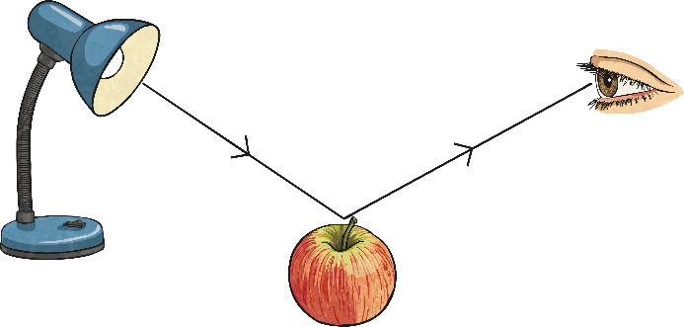 |  | Key Facts
Some animals are nocturnal. They are awake at night and can see very well in the dark.

The moon is not a source of light, it reflects the light from the sun.

UV rays from sun light can be harmful which is why you must protect yourself appropriately.

Light travels in a straight line and is faster than sound.

