Highgate Community Primary School Year 3 Science: Forces and magnets
Vocabulary |  |  | 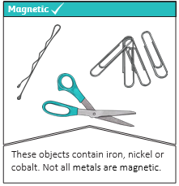  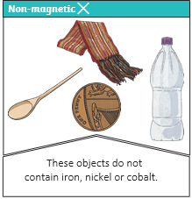 | Key Facts
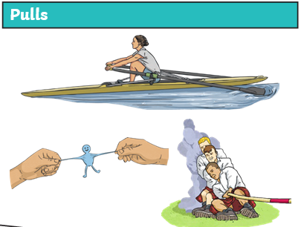
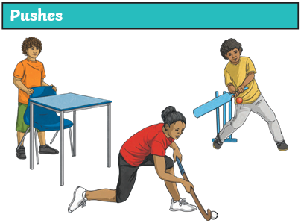
forces | Pushes or pulls.
friction | A force that acts between two surfaces or objects that are moving, or trying to move, across each other.
surface | The top layer of something.
magnet | An object which produces a magnetic force that pulls certain objects towards it.
magnetic | Objects which are attracted to a magnet are magnetic. Objects containing iron, nickel or cobalt metals are magnetic.
poles | North and south poles are found at different ends of a magnet.
repel | Repulsion is a force that pushes objects away. For example, when a north pole is placed near the north pole of another magnet, the two poles repel (push away from each other).
attract | Attraction is a force that pulls objects together. For example, when a north pole is placed near the south pole of another magnet, the two poles attract (pull together).
The same poles repel.  Opposite poles attract.  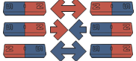 |  | 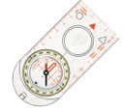  The needle in a compass is a magnet. A compass always points north-south on Earth. | Key Facts
Different surfaces create different amounts of friction. The amount of friction created by an object moving over a surface depends on the roughness of the surface and the object, and the force between them.

Forces will change the motion of an object. They will either make it start to move, speed up, slow it down.

