Highgate Community Primary School Year 3 History: Victorian Leicester
Vocabulary |  | 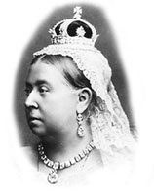  Key Facts  Victorian times means during Victoria's rule. The time Queen Victoria was on the throne. She ruled for 64 years.  There was no electricity, instead gas lamps or candles were used for light.  In 1837 most people lived in villages and worked on the land; by 1901, most lived in towns and worked in offices, shops and factories.  Railways, originally built to transport goods, meant people could travel easily around the country for the first time. Railways brought new foods to towns and cities.  Many households had a servant.  1856 - Police forces now in every town.  New inventions, like the telephone, motorcar, typewriter, bicycle and moving film totally changed the way that people lived, worked and travelled.  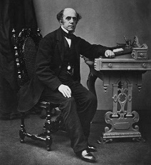  Many poor Victorian children never went to school. Young children were forced to work as soon as they were old enough to earn money for their families.  Thomas Cook was one of the earliest people to organise holidays and leisure activities for different classes of people.
working class | The bottom of the Victorian class system. E.g. a skilled mechanic or a servant.
wealthy | Having a lot of money, land and possessions.
upper class | Wealthy people, often estate owners, who had a lot of money and servants.
drill | Exercises which school children were often made to do in the classroom.
workhouse | Places set up by the government where poor people could go and be given a bed, food and work.
Industrial Revolution | The Industrial Revolution was a period when machine manufacturing grew more common and many people began to work in factories in towns and cities.
government | People chosen by the country to pass laws and run the country.
landmark | A building or feature which is easily noticed and can be used to judge your position or the position of other buildings or features.
transport | ways of travelling around, including roads, railways, undergrounds, and ships.
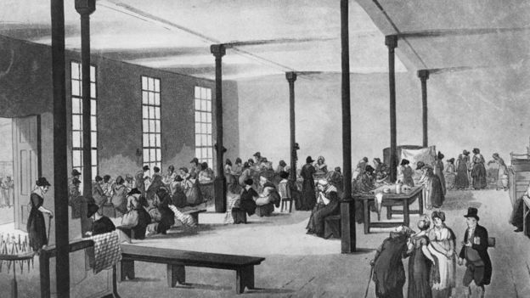
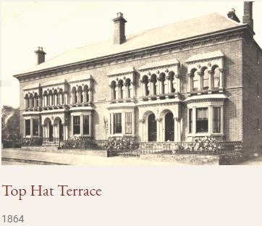

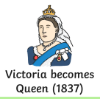
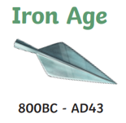
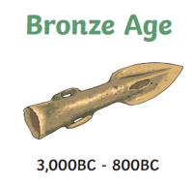
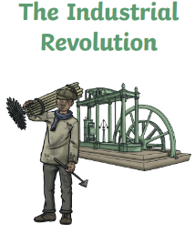
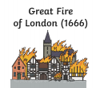
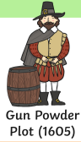
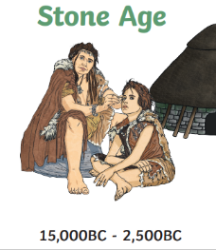
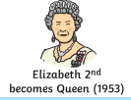
1760-1840

