Highgate Community Primary School Year 3 Design and technology: Food – Healthy and varied diet
Vocabulary |  |  | 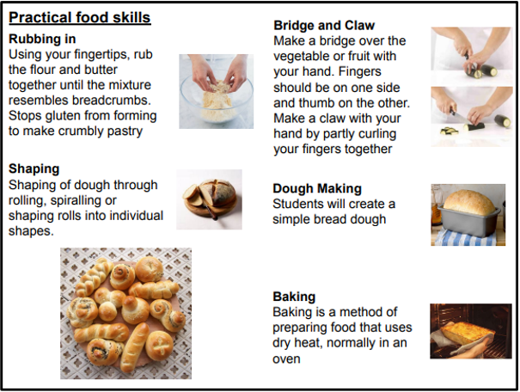
gluten | A protein found in wheat flours that make doughs elastic.
yeast | A microorganism that can spoil food but is used as a raising agent in baking.
kneading | Stretching the dough to develop the gluten and create an elastic dough.
proving | The dough is left to rise.
baking | During baking the heat sets the gluten and stops the yeast from working which allows the bread to set and hold its shape.
knocking back | When you knock back a dough you are creating an evenly textured dough.
bridge hold | Cutting technique whereby one hand is used to make a bridge over the vegetable or fruit with fingers on one side and thumb on the other.
dough | A mixture of flour, yeast and water before it is cooked.
nutrition | The process of providing or obtaining the food  necessary for health and growth.
Taste Test  We will analyse existing products.  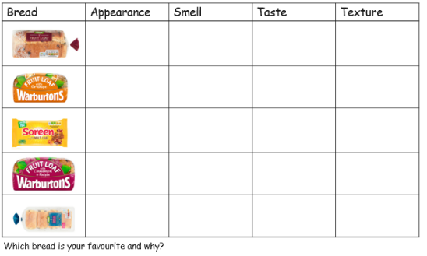 |  | Bread Varieties  • granary  • Chelsea buns  • wholemeal  • fruit bread  • sourdough  • Danish pastries  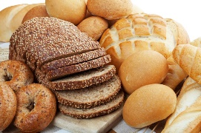  • spelt  • brioche  • rye | Key Facts
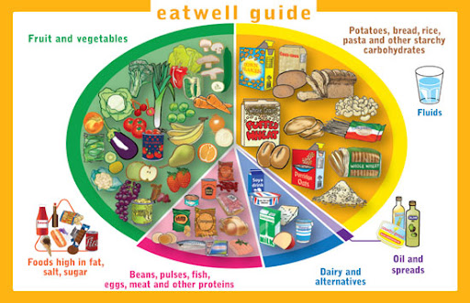
Nutritional value of bread:
• source of starchy carbohydrate
• source of protein
• contains calcium and iron
• good source of fibre

