Highgate Community Primary School Year 3 Key Question: How Can Brahman be Everywhere and in Everything?
Hinduism: Hindu Beliefs
Vocabulary |  |  | Brahman  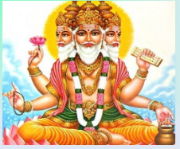  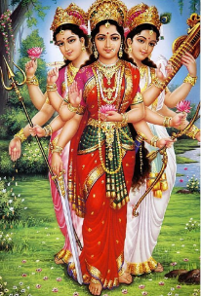  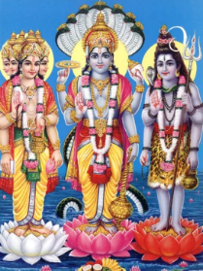  Trimurtis Tridevi | Interesting Facts
Deities in Hinduism are referred to as Deva (masculine) and Devi (feminine)

Brahman is represented by hundreds of different Gods and goddesses

One of the main Gods Ganesh has the body of a boy and the head of an elephant.

Both male and female deities are worshipped with equal reverence in Hinduism
This is also because in Hinduism, god is considered both male and female,
Brahman | The supreme God who is composed of all aspects of life and can take on many different forms.
representation | You can describe a picture, model, or statue of a person or thing as a representation of them.
Aum | This is the sacred symbol of Brahman known as Om or Aum. It is said to be the most suitable name for god as it is a low sound heard during the deepest meditation
Trimurtis | The 3 most important representations of Brahman  Brahma, Vishnu and Shiva
creation | In many religions, creation is the making of the universe, Earth, and creatures by God.
preserver/  sustainer | If you preserve a situation or condition, you make sure that it remains as it is, and does not change or end.
Destroyer | To destroy something means to cause so much damage to it that it is completely ruined or does not exist any more.
Vedas | The Vedas are the oldest and most sacred Hindu texts.
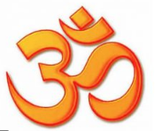  Aum symbol |  | Key Knowledge
Hindus believe in one supreme god, but have many deities (gods and goddesses). Hindus worship one or more of the deities - it doesn't matter which, as they are all seen as different aspects of the one supreme god.
Hindus believe that there are three great gods called the Trimurti. These three gods are:
Vishnu - The god of preservation and protection. Hindus believe that he returns to earth during troubled times to restore the balance between good and evil.
- Brahma - The god of creation. He has four arms and four faces, looking in the four directions.
- Shiva - Shiva is the god of destruction. His role is to destroy the universe in order to recreate it. He is often shown with a third eye.
The Tridevi are goddesses who are equally important. These three goddesses are:
- Saraswati – The goddess (Devi) of knowledge and the arts. She is often shown with a swan or peacock.
Lakshmi - Is the goddess of wealth and purity. Hindus believe that she can bless them with fortune and success.
Shakti - The mother goddess and is the source of all energy, power and creativity in the universe.

